1. **Calculate the average delivery time for restaurants with and without safety measures:**

SELECT Safety_Measure, AVG(Average_Delivery_Time) as AvgDeliveryTime

FROM zomato_rating.zomato_rating

GROUP BY Safety_Measure;

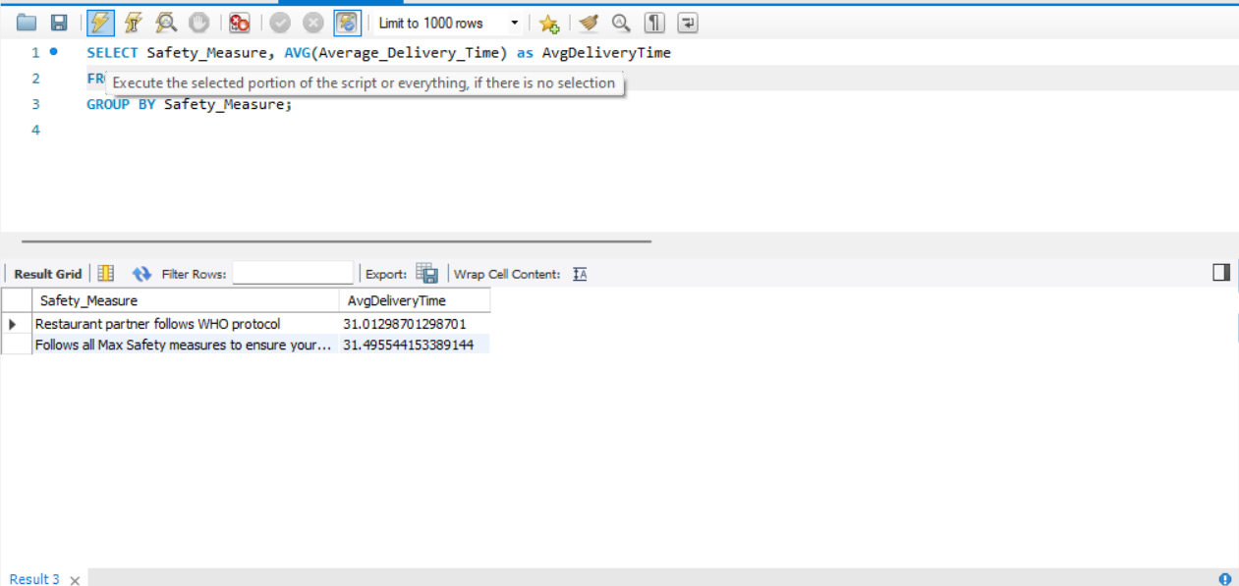

1. **Calculate the weighted average rating for each cuisine, considering both the average rating and the safety measure.**

SELECT Cuisine,

SUM(Rating * Safety_Measure) / SUM(Safety_Measure) as WeightedAvgRating

FROM zomato_rating.zomato_rating

WHERE Safety_Measure IS NOT NULL

GROUP BY Cuisine;

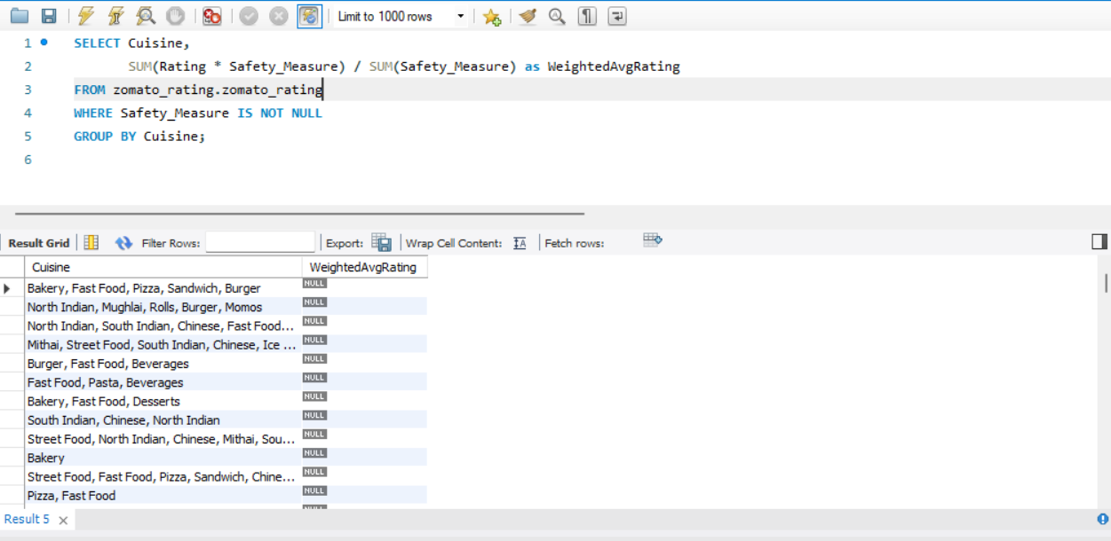

1. **Calculate the average rating and delivery time for each cuisine, considering only restaurants with a safety measure:**

SELECT Cuisine,

AVG(Rating) as AvgRating,

AVG(Average_Delivery_Time) as AvgDeliveryTime

FROM zomato_rating.zomato_rating

WHERE Safety_Measure IS NOT NULL

GROUP BY Cuisine;

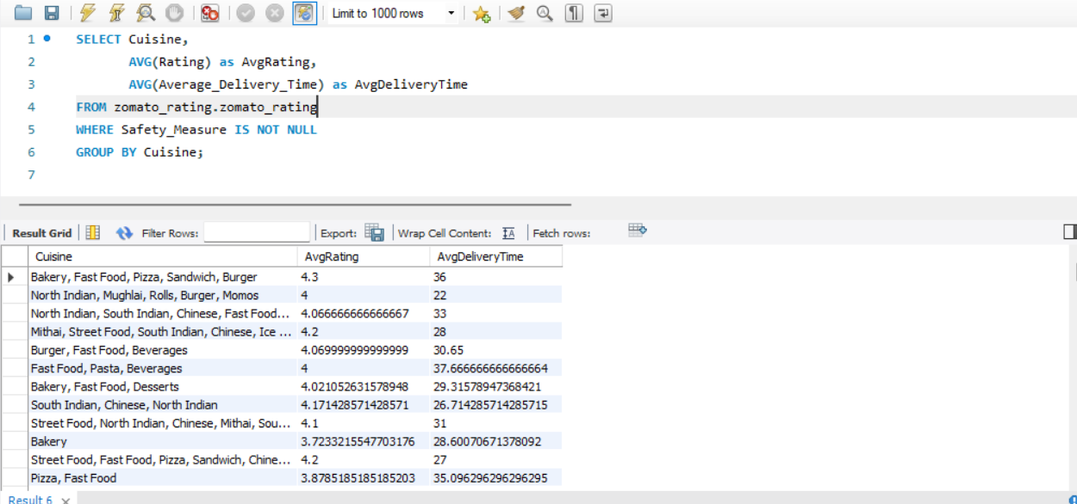

1. **Calculate the cumulative average rating for each restaurant, considering all previous ratings for that restaurant:**

SELECT Restaurant_Name,

Rating,

AVG(Rating) OVER (PARTITION BY Restaurant_Name ORDER BY Rating) as CumulativeAvgRating

FROM zomato_rating;

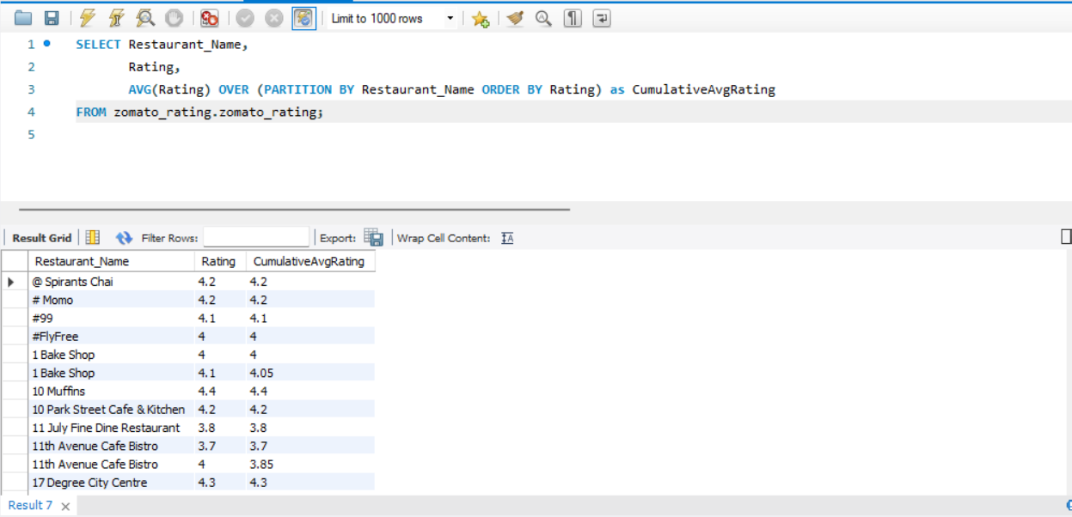

1. **Count the number of restaurants with safety measures in a specific location (e.g., 'City_Name'):**

SELECT COUNT(*) as NumRestaurantsWithSafety

FROM zomato_rating.zomato_rating

WHERE Safety_Measure IS NOT NULL AND Location = 'City_Name';

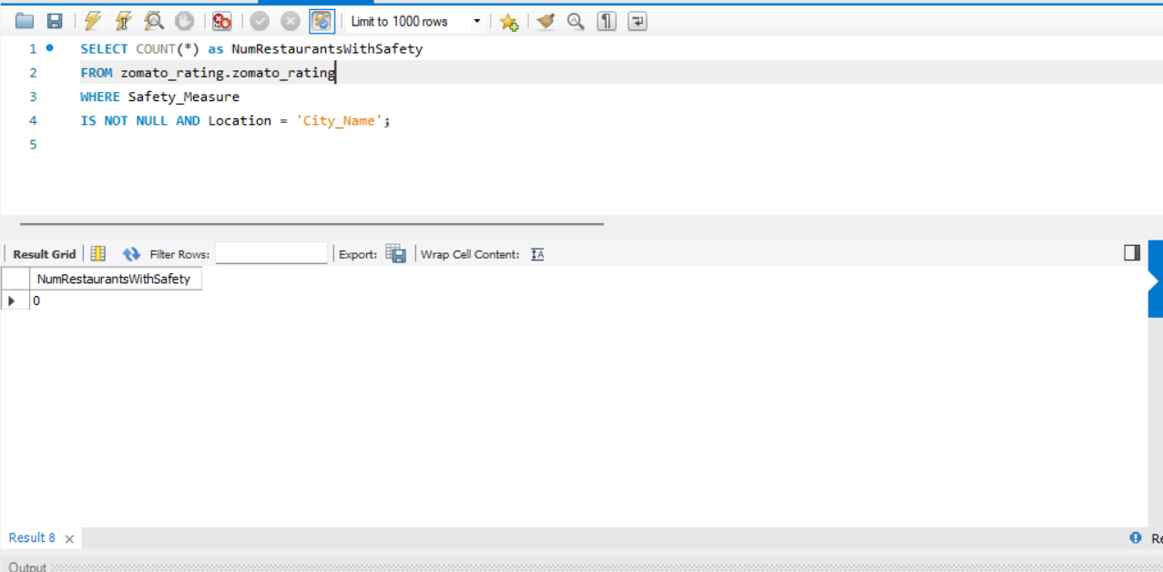

1. **Calculate the cumulative sum of safety measures within each cuisine, ordered by safety measure:**

SELECT Cuisine, Safety_Measure,

SUM(Safety_Measure) OVER (PARTITION BY Cuisine ORDER BY Safety_Measure) as CumulativeSafetySum

FROM zomato_rating.zomato_rating

WHERE Safety_Measure IS NOT NULL;

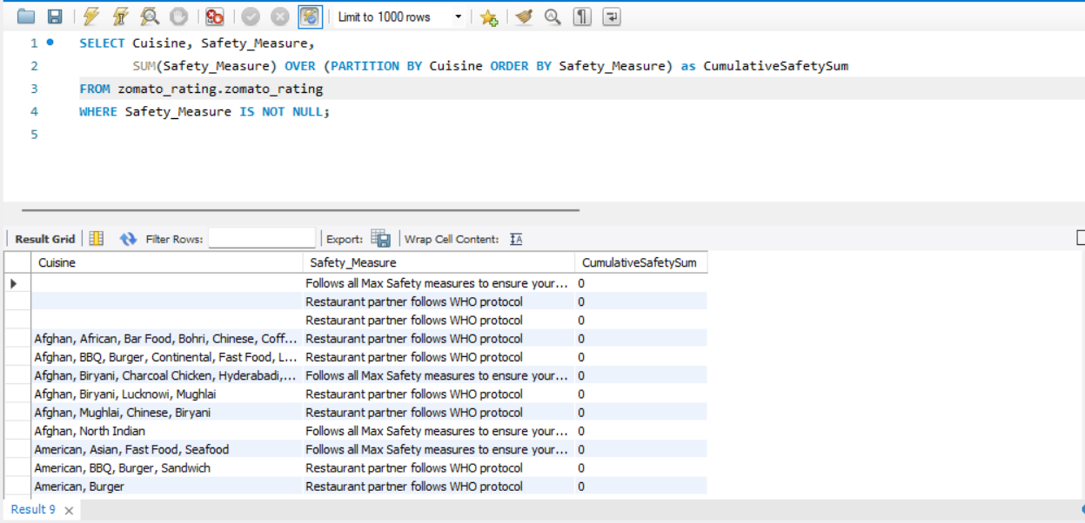

1. **Find the restaurants with an above-average rating and below-average delivery time:**

WITH AvgRatingDelivery AS (

SELECT AVG(Rating) as AvgRating, AVG(Average_Delivery_Time) as AvgDeliveryTime

FROM zomato_rating.zomato_rating

)

SELECT Restaurant_Name, Rating, Average_Delivery_Time

FROM zomato_rating.zo

WHERE Rating > (SELECT AvgRating FROM AvgRatingDelivery)

AND Average_Delivery_Time < (SELECT AvgDeliveryTime FROM AvgRatingDelivery);

1. **Retrieve the top 3 restaurants with the highest safety measures in each cuisine:**

WITH RankedSafetyByCuisine AS (

SELECT Cuisine, Restaurant_Name, Safety_Measure,

RANK() OVER (PARTITION BY Cuisine ORDER BY Safety_Measure DESC) as SafetyRank

FROM zomato_rating.zomato_rating

)

SELECT Cuisine, Restaurant_Name, Safety_Measure

FROM RankedSafetyByCuisine

WHERE SafetyRank <= 3;

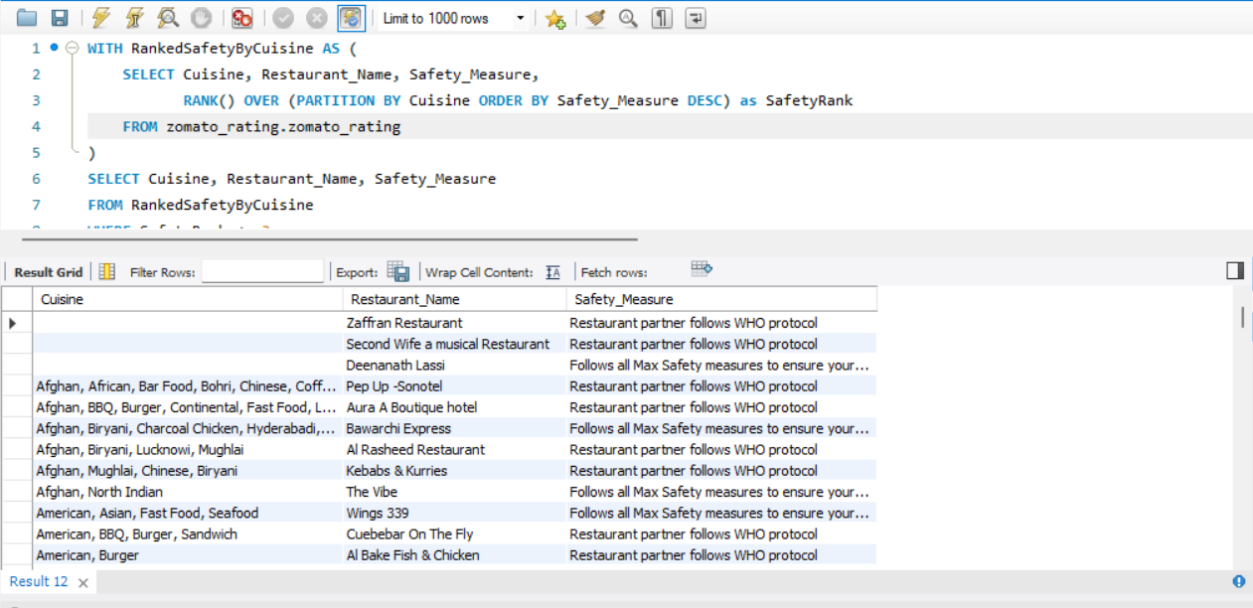

1. **Identify restaurants with a higher-than-average rating and a lower-than-average safety measure:**

WITH AvgRatingSafety AS (

SELECT AVG(Rating) as AvgRating, AVG(Safety_Measure) as AvgSafetyMeasure

FROM zomato_rating.zomato_rating

)

SELECT Restaurant_Name, Rating, Safety_Measure

FROM zomato_rating.zomato_rating

WHERE Rating > (SELECT AvgRating FROM AvgRatingSafety)

AND Safety_Measure < (SELECT AvgSafetyMeasure FROM AvgRatingSafety);

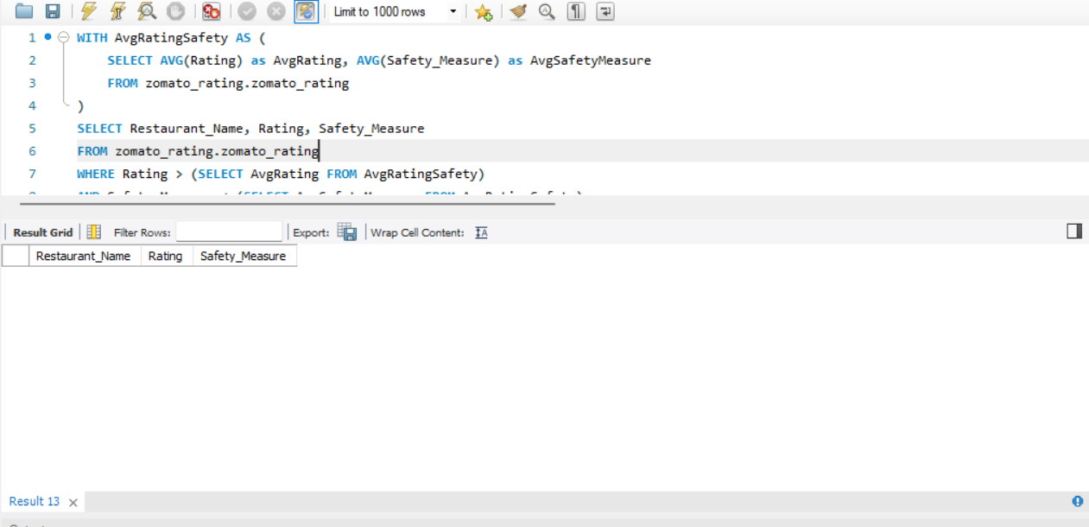

1. **Retrieve the top 5 locations with the highest average rating and safety measure:**

SELECT Location,

AVG(Rating) as AvgRating,

AVG(Safety_Measure) as AvgSafetyMeasure

FROM zomato_rating.zomato_rating

GROUP BY Location

ORDER BY AvgRating DESC, AvgSafetyMeasure DESC

LIMIT 5;

